**RFID BASED SALARY**

**CALCULATOR**

*Minor Project report submitted in partial fulfillment of the requirement for the degree of*

**BACHELOR OF TECHNOLOGY**

**IN**

**ELECTRONICS AND COMMUNICATION ENGINEERING**

By

##### Saloni Sharma(191003)

##### Shalini Siddhi (191047)

**UNDER THE GUIDANCE OF**

Dr. Shweta Pandit



**JAYPEE UNIVERSITY OF INFORMATION TECHNOLOGY, WAKNAGHAT May 2022**

**TABLE OF CONTENTS**

**CAPTION PAGE NO.**

DECLARATION i

ACKNOWLEDGEMENT ii

LIST OF FIGURES iii

ABSTRACT iv

**CHAPTER-1: INTRODUCTION 1**

1.1 Introduction 1

1.2 Objective 1

1.3 Motivation 1

1.4 Language Used 1

1.5 Hardware Required 1

**CHAPTER-2: FEASIBILITY STUDY, REQUIREMENT**

**ANALYSIS, DESIGN AND LITERATURE**

**SURVEY 7**

2.1 Feasibility Study 7

2.1.1 Problem Statement 7

2.1.2 Solution 7

2.2 Requirement Analysis 7

2.3 Design

2.4 Literature survey 7

**CHAPTER-3: IMPLEMENTATION 9**

**CHAPTER-4: RESULTS 21**

**REFERENCES 22**

#### DECLARATION

We hereby declare that the work reported in the B.Tech Project Report entitled **“RFID Based Salary Calculator”** submitted at **Jaypee University of Information Technology, Waknaghat, India** is an authentic record of our work carried out under the supervision of **Dr. Shweta Pandit.** We have not submitted this work elsewhere for any other degree or diploma.

Saloni Sharma Shalini Siddhi

191003 191047

This is to certify that the above statement made by the candidates is correct to the best of my knowledge.

Dr. Shweta Pandit

Date:

Head of the Department/Project Coordinator

**ACKNOWLEDGEMENT**

Firstly, we express our heartiest thanks and gratefulness to Almighty God for His divine blessing in making it possible to complete the project work successfully.

We are really grateful and wish our profound indebtedness to Supervisor **Dr. Shweta Pandit, Assistant Professor (SG)**, Department of ECE Jaypee University of Information Technology, Wakhnaghat. Deep Knowledge & keen interest of our supervisor in the field of “**Cognitive Radio and Wireless Communication**” to carry out this project. Her endless patience, scholarly guidance, continual encouragement, constant and energetic supervision, constructive criticism, valuable advice, reading many inferior drafts, and correcting them at all stages have made it possible to complete this project.

We would like to express our heartiest gratitude to **Dr. Shweta Pandit,**Department of ECE, for her kind help to finish this project.

We would also generously welcome each one of those individuals who have helped us straightforwardly or in a roundabout way in making this project a win. In this unique situation, we might want to thank the various staff individuals, both educating and non-instructing, which have developed their convenient help and facilitated our undertaking.

Finally, we must acknowledge with due respect the constant support and patients of our parents.

Saloni Sharma 191003

Shalini Siddhi 191047

**LIST OF FIGURES**

**Figure 1.1 Jumper wires**

Figure 1.2 Breadboard

Figure 1.3 Buzzer

Figure 1.4 Lcd Display

Figure 1.5 LED

Figure 1.6 RFID tag

Figure 1.7 NodeMCU

Figure 2.1: Block Diagram

Figure 3.1 Circuit made by using NodeMCU Board, and RFID for scaning and storing data into central data base

Figure 3.2 Circuit made by arduino, LCD and RFID to detect no. of taps at main gate

Figure 3.3 : Work flow diagram

Figure 4.1 Names displayed by port after scanning unique RFID tag

Figure 4.2 Salary calculation on google sheet

**ABSTRACT**

RFID( Radio frequency identification ) based salary calculator is developed using two RFID and a card to get the employees’ information . This project can help the retailers and wholesalers to reduce the problems of checking on every employee. The concept is implemented by calculating the

daily working hours of the employee and storing it to the central database and generating the salary accordingly.

In this proposed project we are using the concept of RFID attendance system that is integrated with the database and has a function to store the data or information of every single employee using several main components, such as tags, that will be used as a replacement of ID cards and a reader device that will read the information related to the employee attendance ,but the agenda is to calculate the working hours based on taps by the tag that will indicate the in/out time of the particular employee.

The calculated working hours will help the system to calculate salary of the employees.

Even/odd number of taps at the main gate detected by another RFID scanner will ensure that the employee is not skipping his/her work after entering his in time at the entrance gate.

A tag has a microchip with a special unique number, which is stored in the RFID memory, that is useful in identifying employee’s data individually. An RFID reader is a special device that take a role to interrogate the tags.

If the number of the tag is found in the database, then the system will save the employee id and the name and also the in/ out time into the backend database and display it on LCD connected to node MCU.

Working hours of an employee is found by the system using the in and out time stored in the central

database read by RFID reader 1 at entrance gate and his/her salary is calculated as per his designation in the organization.

In order to ensure that the calculated working hours are valid another RFID reader 2 is used at main gate to detect the number of taps by tag. Odd no of taps will lead to buzzer sound indicating that the employee is not entering valid in time through his/her tag.

This project will help the retailers and wholesalers to give the salary accordingly to the number of hours they have worked .

1.

**CHAPTER 1**

**INTRODUCTION**

## 1.1Introduction

The following document is a report for Minor Project. This project focuses on the reducing the workload of organization by helping them calculate the working hours of their employees.

RFID (radio frequency identification) is a new technology that incorporates the use of electromagnetic or electrostatic coupling in the radio frequency (RF) portion of the electromagnetic spectrum to uniquely identify an object, animal, or person. RFID tags are not an "improved barcode". An RFID system consists of three components: an antenna and transceiver (often combined into one reader) and a transponder(the tag). The antenna uses radio frequency waves to transmit a signal that activates the transponder. When activated, the tag transmits data back to the antenna. RFID technology differs from bar codes. RFID can read the tag using RF, meaning that the RFID reader can be read from a distance, right through your clothes, wallet or purse. Besides the RFID tag consist of unique ID for each tag. The technology used in RFID has been around since the early 1920s.

2.

In our country, this technology is less frequent and the mostly use technology is the biometric systems using finger print. In some places of our country, people prefer to use Barcode which is

cheaper than RFID. As we know the technology spreads very fast and in few years, there is a possibility that RFID will replace the barcode system .

Nowadays, many employees deceive the organization and does not complete their working hoursor send someone else in their place to do their job , to solve this problem the tag will calculate their attendance as well as their working hours .

## 1.2Objective

The main objective of this project is to reduce the effort of administrator to keep the daily events such as payroll, employee performance, and employees details which enhances the productivity of the organization both in terms of manpower and time,all with minimal human interaction.This Project can be very helpful in various corporate sectors, educational institutions, hospitals etc for attendance purpose.

## 

## 1.3Motivation

The application of RFID to employee attendance monitoring as developed and deployed in this study can eliminate time wasted during manual attendance and salary calculating, deceiving of the organization, stressful, cost full after a long period.We can achieve higher accurate automatic personal identification. Furthermore, by using this system it will make calculating salaries more easy to use. Also, RFID has more capability to receive, store and forward data to a remote

3.

source. Hence leads to reduction of work.

**1.4 Programming Languages Used**

* Java programming language for arduino IDE.
* PHP: All the Logics and web interface is written in PHP Language.
* MYSQL: For database, MYSQL Database is used.
* Javascript for google sheet code

**1.5 Hardware Requirements**

* Jumper wires: A jump wire (also known as jumper, jumper wire, DuPont wire) is an electrical wire, or group of them in a cable, with a connector or pin at each end which is normally used to interconnect the components of a breadboard or other prototype or test circuit, internally or with other equipment or components without soldering.

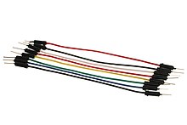

**Figure 1.1** Jumper wires

* Bread board : A breadboard, or proto board, is a construction base for prototyping of electronics. Originally the word referred to a literal bread board, a polished piece of wood used when slicing bread. In the 1970s the solderless breadboard (a.k.a. plugboard, a terminal array board) became available and nowadays the term "breadboard" is commonly used to refer to these.

4.

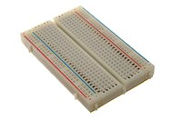

**Figure 1.2** Breadboard

* Buzzer : A buzzer or beeper is an audio signaling device, which may be mechanical, or electro mechanical .Typical uses of buzzers and beepers include alarm devices, timers, train and confirmation of user input such as a mouse click or keystroke.

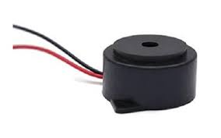

**Figure 1.3** Buzzer

* Lcd display : LCD (Liquid Crystal Display) is a type of flat panel display which uses liquid crystals in its primary form of operation. LEDs have a large and varying set of use cases for consumers and businesses, as they can be commonly found in smart phones, televisions, computer monitors .

5.

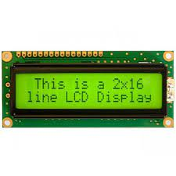

**Figure 1.4** Lcd Display

* LED : A Light Emitting Diode (LED) is a P-N junction diode which emits visible light when energized An LED allows the flow of electric current only in one direction and more to that produces monochromatic radiations or inconsistent polychromatic radiations because of the conversion of electrical energy when current passes through it.

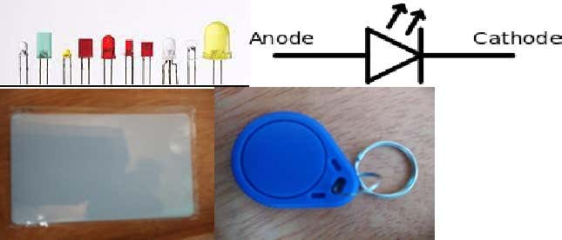

**Figure 1.5** LED

* RFID reader and tags :The tag also known as the transponder, holds the data that is transmitted to the reader when the tag is interrogated by the reader. The most common tags today consist of an Integrated Circuit with memory, essentially a microprocessor chip. Other tags are chip less and have no on board Integrated circuit. Chip less tags are more effective in applications where simpler range of function is all that is required although they can help achieve more accuracy and better detection range at potentially lower cost than their Integrated Circuit-based counterparts. From here on out, we will use the term tag to mean Integrated Circuit-based tag. We will refer to chip less tags explicitly when needed.

6.



**Figure 1.6** RFID tag

NodeMCU : NodeMCU is an open-source LUA based firmware developed for the ESP8266 wifi chip. By exploring functionality with the ESP8266 chip, NodeMCU firmware comes with the ESP8266 Development board/kit i.e. NodeMCU Development board. Since NodeMCU is an open-source platform, its hardware design is open for edit/modify/build.

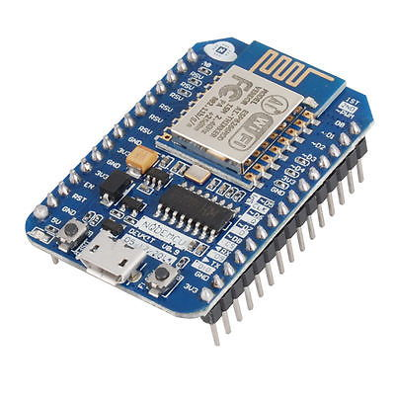

**Figure 1.7** NodeMCU

**7.**

**CHAPTER 2**

**Feasibility Study, Requirement Analysis, Design and Literature review**

**2.1 Feasibility Study**

**2.1.1 Problem Definition**

Many employees deceives the organization by either not working for the given time slot or by sending someone else to work on their behalf . The organization still gives them salary without knowing the actual picture . Also , it may happen that an employee taps once and leave the organization without fulfilling the duty and gets the invalid salary.

**2.1.2 Solution**

To cope up with this problem the RFID based salary calculator will calculate the working hours of the employees and also the time they go in/out of the organization during their working hours ,this will help the organization to keep in track the amount of time employee is giving to the work.

Even- odd strategy is used to ensure that valid working hours are calculated.

**2.2 Requirement Analysis**

We just need  **NodeMCU ,Board, and RFID.**This is the simple network topology designed to run this project over a Local Area Network. The Project Device and Computer server are connected to the same network through WiFi.Here we are building an IoT based salary calculator which can store the data in Google sheet. A NodeMCU module will be interfaced with an LCD display, and Google spreadsheet will be used to keep the attendance log for future references.

8.

**2.3 Design**

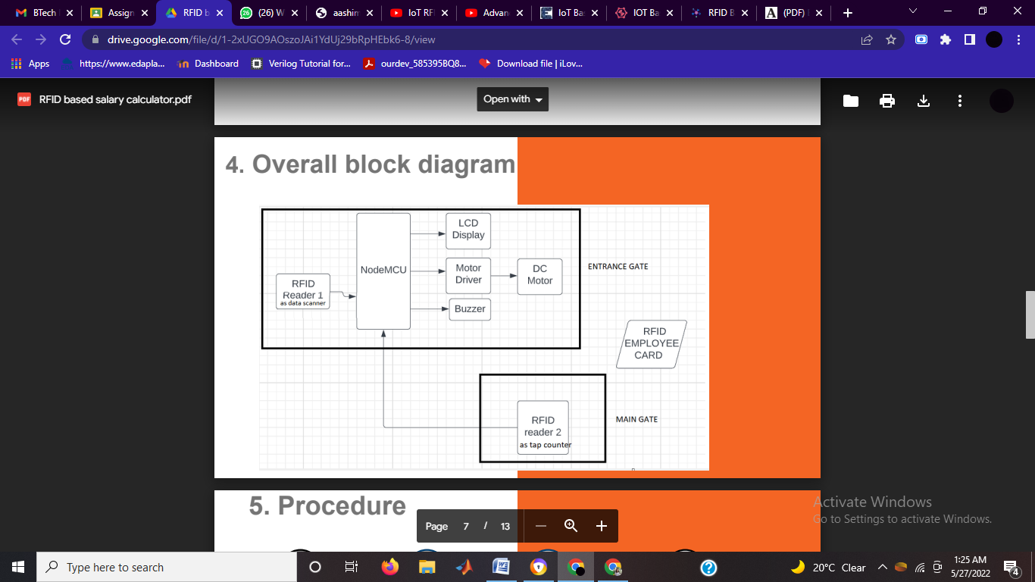

**Figure 2.1**: Block Diagram

In the above block diagram we can see that we have used two RFID readers , one RFID is used to store the database of the employee and display on the LCD and other is used to calculate the numbers of taps if the taps are even or odd ,if the taps are odd then the buzzer will go on and , if the taps are even then the employee has worked for valid working hours which will be used to calculate

the salary of the employee.

**2.4 Literature Review**

Before the RFID system smart-card and barcode are more popular for all purpose like supervision, attendance or for monitoring student, employees etc. In this we are going to implement the RFID system in our project for improvement of old attendance system and checking system for better result and security of the student. An RFID tag is an object that can be applied to or inserted into a product, person or animal for identification and tracking using radio waves. Some identifier scan be read from several centimeters or meters away and beyond the line of sight of the reader. Several related works exist in works application of RFID Technology to different areas andspecifically to the area of academic attendance monitoring problem. In authors designed and employed a model of a secured and portable embedded reader system to read the biometric data from the electronic passport. The authors attempted to solve problems of trustworthiness security and confidentiality in

9.

E-passports by authenticating holder online using Global System of Mobile Communications (GSM) network. The GSM network is the main edge between identification center and the e passport reader. The communication data is protected between server and e-passport reader by using AES to translate data for protection while transferring through GSM network. The use of Radio-frequency identification (RFID) technology in automated electronic environment and for tracking objects has been widely researched upon by researchers and deployed by various organizations as part of their automation systems. RFID is a technology that uses radio waves to transfer data from an electronic tag, called RFID tag or label attached to an object through a reader for identifying and tracking the object.

* In this proposed project we are using the same concept of RFID attendance system that is integrated with the database and has a function to store the data or information of every single employee using several main components such as tags that will be used as a replacement of ID cards and a reader device that will read the information related to the employee attendance but the agenda is to calculate the working hours based on taps by the tag indicating in/out time of the particular employee.
* The calculated working hours will help the system to calculate salary based on his/her designation in the organization.
* Even/odd no of taps at the main gate detected by another RFID scanner will ensure that the employee is not skipping his/her work after entering his in time at the entrance gate.

**CHAPTER 3**

**Implementation**

A tag has a microchip with a special unique number, which is stored in the RFID memory, that is useful in identifying employee’s data individually. An RFID reader is a special device that take a role to interrogate the tags.

If the number of the tag is found in the database, then the system will save the employee id and the name and also the in/ out time into the backend database and display it on LCD connected to node MCU.

Working hours of an employee is found by the system using the in and out time stored in the central

10.

database read by RFID reader 1 at entrance gate and his/her salary is calculated as per his designation in the organization.

In order to ensure that the calculated working hours are valid another RFID reader 2 is used at main gate to detect the number of taps by tag. Odd no of taps will lead to buzzer sound indicating that the employee is not entering valid in time through his/her tag.

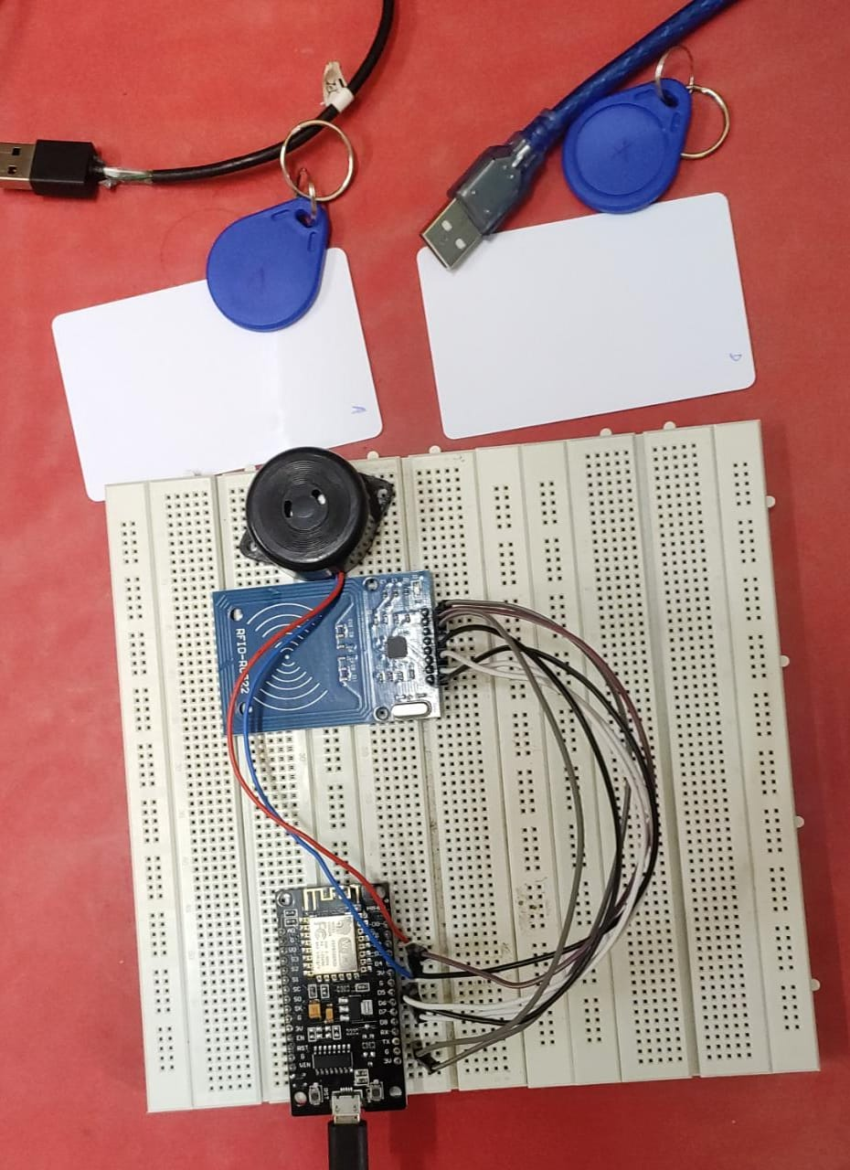

**Figure 3.1** Circuit made by using **NodeMCU Board, and RFID for scaning and storing data into central data base**

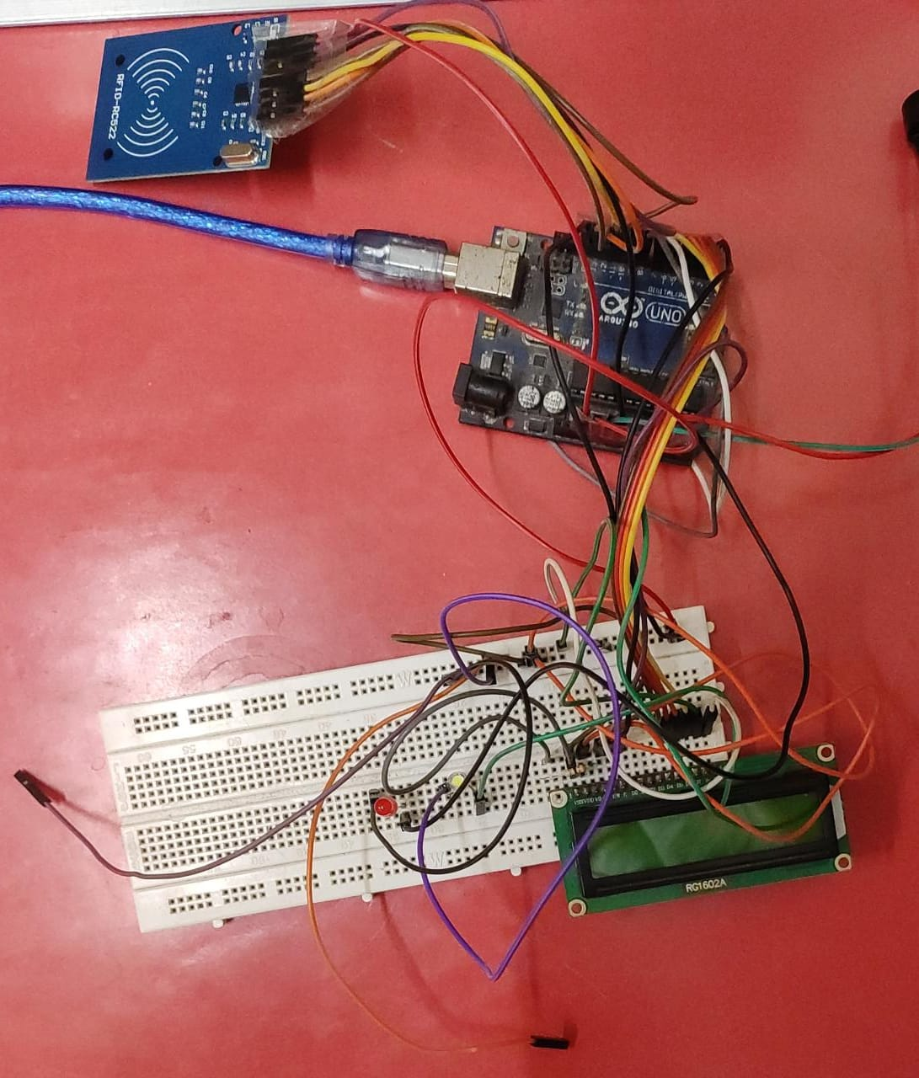

**Figure 3.2** Circuit made by arduino, LCD and RFID to detect no. of taps at main gate

**Code to write data on unique card/tag**

#include <SPI.h>

11.

#include <MFRC522.h>

const uint8_t RST_PIN = D3; // Configurable, see typical pin layout above

const uint8_t SS_PIN = D4; // Configurable, see typical pin layout above

MFRC522 mfrc522(SS_PIN, RST_PIN); // Instance of the class

MFRC522::MIFARE_Key key;

/* Set the block to which we want to write data */

/* Be aware of Sector Trailer Blocks */

int blockNum = 2;

/* Create an array of 16 Bytes and fill it with data */

/* This is the actual data which is going to be written into the card */

byte blockData [16] = {"Aditya_Tomar"};

/* Create another array to read data from Block */

/* Legthn of buffer should be 2 Bytes more than the size of Block (16 Bytes) */

byte bufferLen = 18;

byte readBlockData[18];

MFRC522::StatusCode status;

void setup()

{

/* Initialize serial communications with the PC */

Serial.begin(9600);

/* Initialize SPI bus */

SPI.begin();

/* Initialize MFRC522 Module */

mfrc522.PCD_Init();

Serial.println("Scan a MIFARE 1K Tag to write data...");

}

void loop()

{

/* Prepare the ksy for authentication */

/* All keys are set to FFFFFFFFFFFFh at chip delivery from the factory */

for (byte i = 0; i < 6; i++)

{

key.keyByte[i] = 0xFF;

}

/* Look for new cards */

12.

/* Reset the loop if no new card is present on RC522 Reader */

if ( ! mfrc522.PICC_IsNewCardPresent())

{

return;

}

/* Select one of the cards */

if ( ! mfrc522.PICC_ReadCardSerial())

{

return;

}

Serial.print("\n");

Serial.println("Card Detected");

/* Print UID of the Card */

Serial.print(F("Card UID:"));

for (byte i = 0; i < mfrc522.uid.size; i++)

{

Serial.print(mfrc522.uid.uidByte[i] < 0x10 ? " 0" : " ");

Serial.print(mfrc522.uid.uidByte[i], HEX);

}

Serial.print("\n");

/* Print type of card (for example, MIFARE 1K) */

Serial.print(F("PICC type: "));

MFRC522::PICC_Type piccType = mfrc522.PICC_GetType(mfrc522.uid.sak);

Serial.println(mfrc522.PICC_GetTypeName(piccType));

/* Call 'WriteDataToBlock' function, which will write data to the block */

Serial.print("\n");

Serial.println("Writing to Data Block...");

WriteDataToBlock(blockNum, blockData);

/* Read data from the same block */

Serial.print("\n");

Serial.println("Reading from Data Block...");

ReadDataFromBlock(blockNum, readBlockData);

/* If you want to print the full memory dump, uncomment the next line */

//mfrc522.PICC_DumpToSerial(&(mfrc522.uid));

/* Print the data read from block */

Serial.print("\n");

Serial.print("Data in Block:");

Serial.print(blockNum);

Serial.print(" --> ");

13.

for (int j=0 ; j<16 ; j++)

{

Serial.write(readBlockData[j]);

}

Serial.print("\n");

}

void WriteDataToBlock(int blockNum, byte blockData[])

{

/* Authenticating the desired data block for write access using Key A */

status = mfrc522.PCD_Authenticate(MFRC522::PICC_CMD_MF_AUTH_KEY_A,

blockNum, &key, &(mfrc522.uid));

if (status != MFRC522::STATUS_OK)

{

Serial.print("Authentication failed for Write: ");

Serial.println(mfrc522.GetStatusCodeName(status));

return;

}

else

{

Serial.println("Authentication success");

}

/* Write data to the block */

status = mfrc522.MIFARE_Write(blockNum, blockData, 16);

if (status != MFRC522::STATUS_OK)

{

Serial.print("Writing to Block failed: ");

Serial.println(mfrc522.GetStatusCodeName(status));

return;

}

else

{

Serial.println("Data was written into Block successfully");

}

}

void ReadDataFromBlock(int blockNum, byte readBlockData[])

{

14.

/* Authenticating the desired data block for Read access using Key A */

status = mfrc522.PCD_Authenticate(MFRC522::PICC_CMD_MF_AUTH_KEY_A, blockNum, &key, &(mfrc522.uid));

if (status != MFRC522::STATUS_OK)

{

Serial.print("Authentication failed for Read: ");

Serial.println(mfrc522.GetStatusCodeName(status));

return;

}

else

{

Serial.println("Authentication success");

}

/* Reading data from the Block */

status = mfrc522.MIFARE_Read(blockNum, readBlockData, &bufferLen);

if (status != MFRC522::STATUS_OK)

{

Serial.print("Reading failed: ");

Serial.println(mfrc522.GetStatusCodeName(status));

return;

}

else

{

Serial.println("Block was read successfully");

}

}

**Google sheet app script to add data on tap**

function doGet(e) {

Logger.log( JSON.stringify(e) );

var result = 'Ok';

if (e.parameter == 'undefined') {

result = 'No Parameters';

}

else {

var sheet_id = '1x4IaY-KvFjSi6nzYw__7SBPa7r401VlNbJqE1oRZnPU'; // Spreadsheet ID

var sheet = SpreadsheetApp.openById(sheet_id).getActiveSheet();

15.

var newRow = sheet.getLastRow() + 1;

var rowData = [];

var Curr_Date = new Date();

rowData[0] = Curr_Date; // Date in column A

var Curr_Time = Utilities.formatDate(Curr_Date, "Asia/Kolkata", 'HH:mm:ss');

rowData[1] = Curr_Time; // Time in column B

for (var param in e.parameter) {

Logger.log('In for loop, param=' + param);

var value = stripQuotes(e.parameter[param]);

Logger.log(param + ':' + e.parameter[param]);

switch (param) {

case 'name':

rowData[2] = value; // Employee Name in column C

result = 'Employee Name Written on column C';

break;

default:

result = "unsupported parameter";

}

}

Logger.log(JSON.stringify(rowData));

var newRange = sheet.getRange(newRow, 1, 1, rowData.length);

newRange.setValues([rowData]);

}

return ContentService.createTextOutput(result);

}

function stripQuotes( value ) {

return value.replace(/^["']|['"]$/g, "");

}

**Code to send the tapped card data into google sheet for salary calculation**

#include <SPI.h>

#include <MFRC522.h>

#include <Arduino.h>

#include <ESP8266WiFi.h>

#include <ESP8266WiFiMulti.h>

#include <ESP8266HTTPClient.h>

#include <WiFiClient.h>

#include <WiFiClientSecureBearSSL.h>

16.

// Fingerprint for demo URL needs to be updated well before this date dde76b0a789fda46ab843ed7f40275417662cad3

const uint8_t fingerprint[20] = {0xdd, 0xe7, 0x6b, 0x0a, 0x78, 0x9f, 0xda, 0x46, 0xab, 0x84, 0x3e, 0xd7, 0xf4, 0x02, 0x75, 0x41, 0x76, 0x62, 0xca, 0xd3};

// dde76b0a789fda46ab843ed7f40275417662cad3

#define RST_PIN D3 // Configurable, see typical pin layout above

#define SS_PIN D4 // Configurable, see typical pin layout above

#define BUZZER D2 // Configurable, see typical pin layout above

MFRC522 mfrc522(SS_PIN, RST_PIN); // Instance of the class

MFRC522::MIFARE_Key key;

ESP8266WiFiMulti WiFiMulti;

MFRC522::StatusCode status;

/* Be aware of Sector Trailer Blocks */

int blockNum = 2;

/* Create another array to read data from Block */

/* Legthn of buffer should be 2 Bytes more than the size of Block (16 Bytes) */

byte bufferLen = 18;

byte readBlockData[18];

String data2;

const String data1 = "https://script.google.com/macros/s/AKfycbyeV9JJC1mqvCkTUyytpE54Qva8mS-Kb8TEIsjdgja5IgJtOZaz5ZxncBEzfdpdyrhn/exec?name=";

void setup()

{

/* Initialize serial communications with the PC */

Serial.begin(9600);

// Serial.setDebugOutput(true);

Serial.println();

Serial.println();

Serial.println();

for (uint8_t t = 4; t > 0; t--)

{

Serial.printf("[SETUP] WAIT %d...\n", t);

17.

Serial.flush();

delay(1000);

}

WiFi.mode(WIFI_STA);

/* Put your WIFI Name and Password here */

WiFiMulti.addAP("myproject", "12345678");

/* Set BUZZER as OUTPUT */

pinMode(BUZZER, OUTPUT);

/* Initialize SPI bus */

SPI.begin();

}

void loop()

{

/* Initialize MFRC522 Module */

mfrc522.PCD_Init();

/* Look for new cards */

/* Reset the loop if no new card is present on RC522 Reader */

if ( ! mfrc522.PICC_IsNewCardPresent())

{

return;

}

/* Select one of the cards */

if ( ! mfrc522.PICC_ReadCardSerial())

{

return;

}

/* Read data from the same block */

Serial.println();

Serial.println(F("Reading last data from RFID..."));

ReadDataFromBlock(blockNum, readBlockData);

/* If you want to print the full memory dump, uncomment the next line */

//mfrc522.PICC_DumpToSerial(&(mfrc522.uid));

/* Print the data read from block */

Serial.println();

Serial.print(F("Last data in RFID:"));

Serial.print(blockNum);

Serial.print(F(" --> "));

18.

for (int j=0 ; j<16 ; j++)

{

Serial.write(readBlockData[j]);

}

Serial.println();

digitalWrite(BUZZER, HIGH);

delay(200);

digitalWrite(BUZZER, LOW);

delay(200);

digitalWrite(BUZZER, HIGH);

delay(200);

digitalWrite(BUZZER, LOW);

// wait for WiFi connection

if ((WiFiMulti.run() == WL_CONNECTED))

{

std::unique_ptr<BearSSL::WiFiClientSecure>client(new BearSSL::WiFiClientSecure);

client->setFingerprint(fingerprint);

// Or, if you happy to ignore the SSL certificate, then use the following line instead:

// client->setInsecure();

data2 = data1 + String((char*)readBlockData);

data2.trim();

Serial.println(data2);

HTTPClient https;

Serial.print(F("[HTTPS] begin...\n"));

if (https.begin(*client, (String)data2))

{

// HTTP

Serial.print(F("[HTTPS] GET...\n"));

// start connection and send HTTP header

int httpCode = https.GET();

// httpCode will be negative on error

if (httpCode > 0)

{

// HTTP header has been send and Server response header has been handled

Serial.printf("[HTTPS] GET... code: %d\n", httpCode);

// file found at server

}

19.

else

{

Serial.printf("[HTTPS] GET... failed, error: %s\n", https.errorToString(httpCode).c_str());

}

https.end();

delay(1000);

}

else

{

Serial.printf("[HTTPS} Unable to connect\n");

}

}

}

void ReadDataFromBlock(int blockNum, byte readBlockData[])

{

/* Prepare the ksy for authentication */

/* All keys are set to FFFFFFFFFFFFh at chip delivery from the factory */

for (byte i = 0; i < 6; i++)

{

key.keyByte[i] = 0xFF;

}

/* Authenticating the desired data block for Read access using Key A */

status = mfrc522.PCD_Authenticate(MFRC522::PICC_CMD_MF_AUTH_KEY_A, blockNum, &key, &(mfrc522.uid));

if (status != MFRC522::STATUS_OK)

{

Serial.print("Authentication failed for Read: ");

Serial.println(mfrc522.GetStatusCodeName(status));

return;

}

else

{

Serial.println("Authentication success");

}

/* Reading data from the Block */

status = mfrc522.MIFARE_Read(blockNum, readBlockData, &bufferLen);

if (status != MFRC522::STATUS_OK)

{

20.

Serial.print("Reading failed: ");

Serial.println(mfrc522.GetStatusCodeName(status));

return;

}

else

{

Serial.println("Block was read successfully");

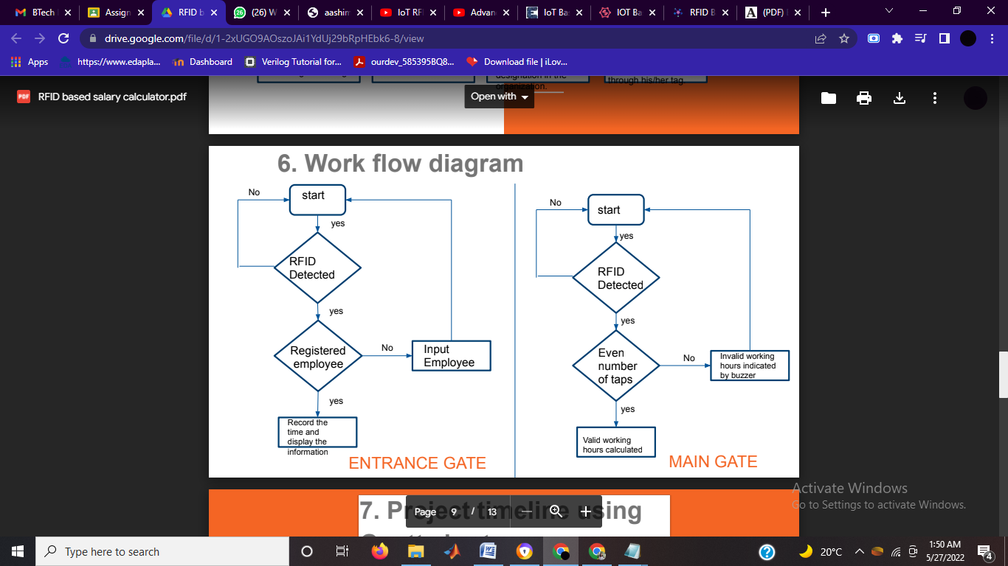

**Figure 3.3** Work flow diagram

21.

**CHAPTER 4**

**Results**

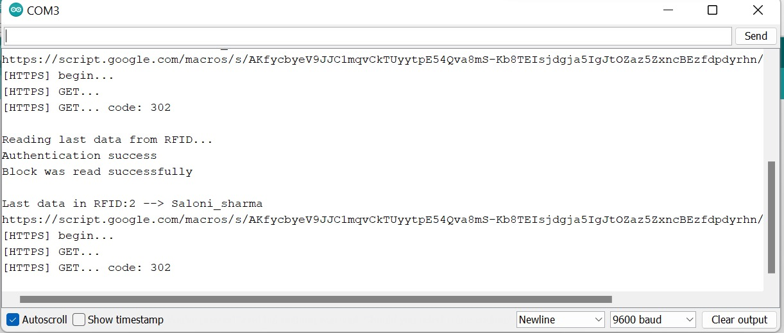

**Figure 4.1** Names displayed by port after scanning unique RFID tag

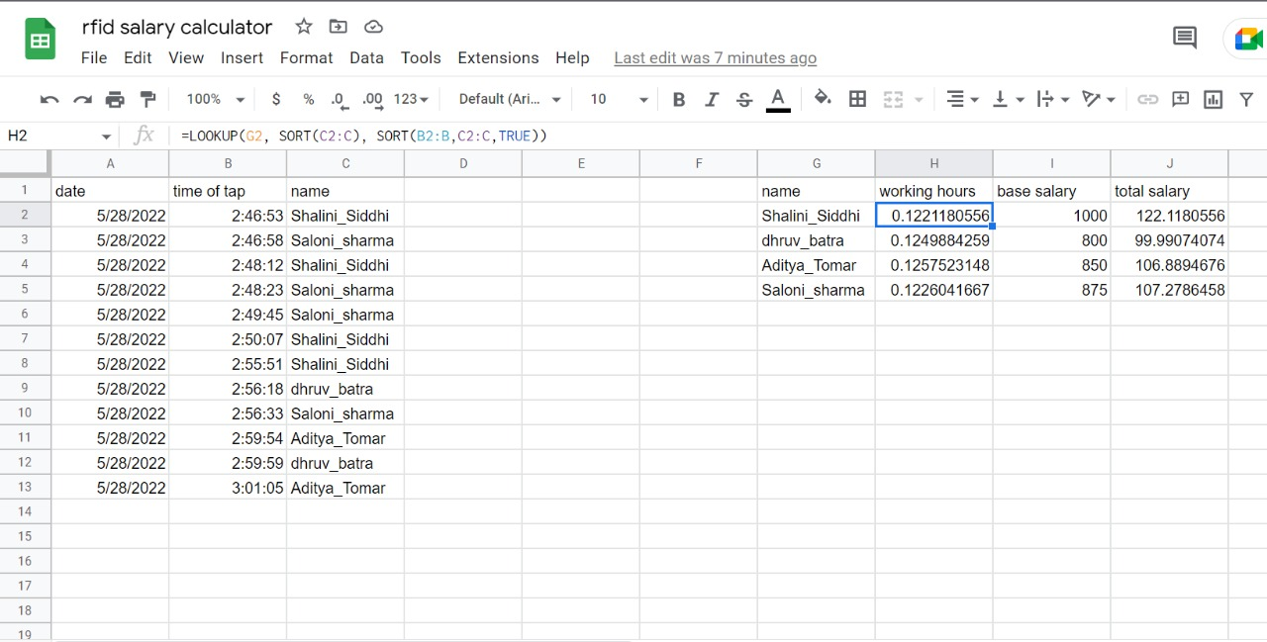

**Figure 4.2** Salary calculation on google sheet

22.

**References**

[1] Navaneeth S., Megha P.M., Sruji N. M., Anusha T. R.and Haritha S.

“Students Smart Card using RFID” , International Research Journal of Engineering and Technology

(IRJET)

Volume: 05 Issue: 04 | Apr-2018

[2] G D P Maramis and P T D Rompas

“Radio Frequency Identification (RFID) Based Employee Attendance Management System”, IOP

Conf. Series: Materials Science and Engineering 306 (2018)

[3] Rizwan Qureshi

“THE PROPOSED IMPLEMENTATION OF RFID BASED ATTENDANCE SYSTEM”, International Journal of Software Engineering & Applications (IJSEA)

Vol.11, No.3, May 2020

[4] Hasanein D. Rjeib

“Attendance and Information System using RFID and Web-Based Application for Academic Sector”, (IJACSA) International Journal of Advanced Computer Science and Applications,

Vol. 9, No. 1, 2018

[5] Ms.G.T.Bharathy1, Ms.S.Bhavanisankari1 and T.Tamilselvi

“Smart Attendance Monitoring System using IoT and RFID”, (IJACSA) International Journal of Advances in engineering and management

Vol. 3, Issue 6 June 2021